CAPSTONE PROJECT 9 INTEGRATED RETAIL ANALYTICS

A large retail chain operating 45 stores across multiple regions needs to optimise store performance, forecast weekly demand at the store department level, and design personalised marketing and inventory strategies

DATA UNDERSTANDING

OVERVIEW:
Three raw source tables are loaded and profiled to understand the data available before any transformation. The tables are stores (45 rows × 3 columns), sales (421,570 rows × 5 columns), and features (8,190 rows × 12 columns). The sales table is the transactional spine recorded at the store department week grain. The stores table supplies static attributes, store Type (A, B, C) and physical Size. The features table carries time-varying external context including CPI, Unemployment, Fuel Price, Temperature, and five promotional markdown channels.

METHOD:
1. All three datasets are loaded using pandas and their shapes are confirmed.
2. A firstview check displays the head, datatypes, and descriptive statistics for each table.
3. Row and column counts are reported: stores (45 × 3), sales (421,570 × 5), features (8,190 × 12).
4. Duplicate checks confirm zero duplicates across all three tables.
5. A missing-value audit reveals the sales and stores tables are fully populated. The features table has structural gaps in all five MarkDown columns (50–64% missing) because promotional tracking only began in November 2011, and small trailing gaps in CPI and Unemployment (7.1% each).

SCREENSHOT:
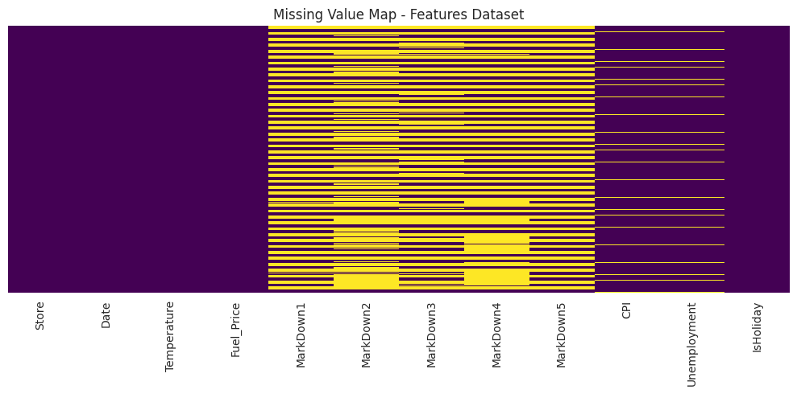
Missing Value Map Features Dataset

The heatmap shows missing values (yellow) across the features table. The MarkDown1 through MarkDown5 columns are heavily missing (50–64%), with the gaps concentrated in the earlier rows corresponding to dates before November 2011. CPI and Unemployment show a smaller gap at the tail end of the series. Store, Date, Temperature, Fuel_Price, and IsHoliday are fully populated with no missing values.

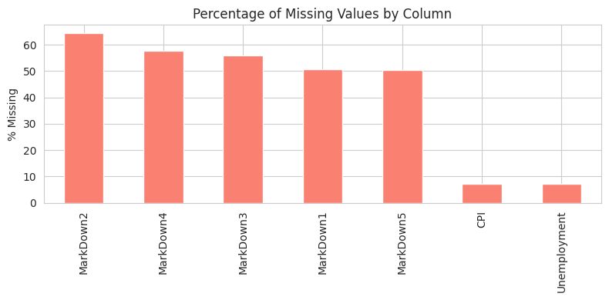
Percentage of Missing Values by Column

The bar chart ranks each column by its missing-value percentage. MarkDown2 has the highest missingness at 64.3%, followed by MarkDown4 (57.7%), MarkDown3 (55.9%), MarkDown1 (50.8%), and MarkDown5 (50.6%). CPI and Unemployment each sit at 7.1%. This structural gap in markdown data is not random — it reflects the business reality that promotional tracking was introduced only from late 2011 onward.

KEY DATASET FACTS:
- 45 stores across Types A (22), B (17), C (6)
- 81 unique departments
- 143 consecutive weeks from February 2010 to October 2012
- 421,570 total sales records after merging
- Zero duplicates in all three source tables

DATA WRANGLING

WORKFLOW OVERVIEW:
The three source tables are merged into a single analysis-ready master table of 421,570 rows and 22 columns. Calendar features and a consolidated markdown field are engineered during this stage. The merge order is important: sales is the spine, store attributes are joined first, then external features are layered on.

HOW IT WORKS:
1. Sales is merged with Stores on the Store key (left join) to attach Type and Size to every sales row.
2. The result is merged with Features on Store + Date (left join). The duplicate IsHoliday column from Features is dropped to avoid a clash with the authoritative flag in Sales.
3. Calendar features are extracted from the Date column: Year, Month, Week-of-year, Day, and Day-of-year.
4. A Total_MarkDown field is created by summing MarkDown1 through MarkDown5 with min_count=1, preserving the distinction between no-promotion-recorded and zero-promotion.
5. The final master table is confirmed in shape (421,570, 22) with all join keys intact.

TABLE COLUMNS:
- From Sales: Store, Dept, Date, Weekly_Sales, IsHoliday
- From Stores: Type, Size
- From Features: Temperature, Fuel_Price, MarkDown1–5, CPI, Unemployment
- Engineered: Year, Month, Week, Day, DayOfYear, Total_MarkDown

EXPLORATORY DATA ANALYSIS (EDA)

WORKFLOW OVERVIEW:
Fifteen charts are produced following the UBM principle — Univariate, Bivariate, then Multivariate analysis. The goal is to surface the structure of the business before any modelling so that later feature and model choices are grounded in observed behaviour. A representative selection of the most decision-relevant charts is shown below.

SCREENSHOT:
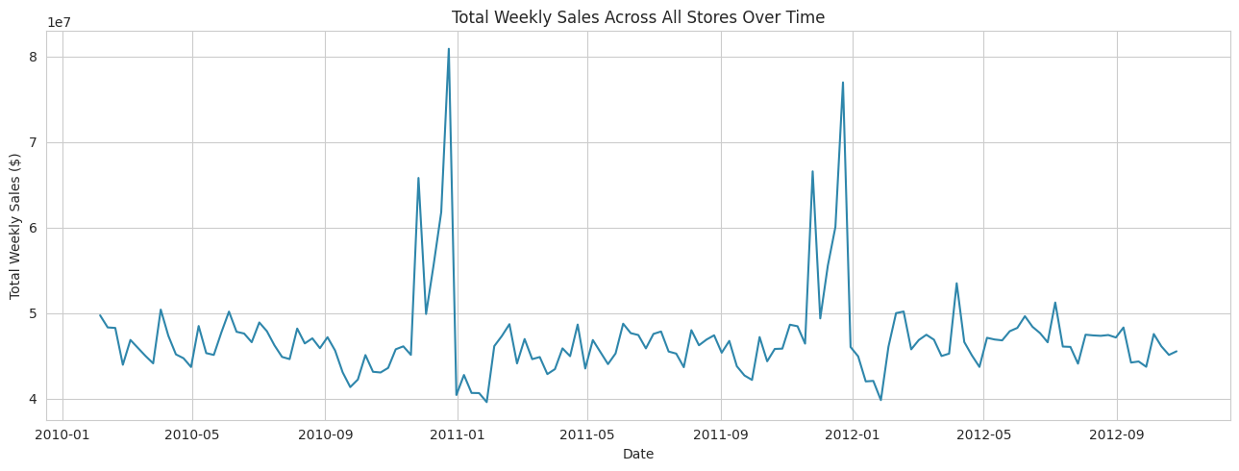
Chart 1: Total Weekly Sales Across All Stores Over Time

The time series line shows total weekly sales across all 45 stores from February 2010 to October 2012. The baseline is stable around the $40 per week level, but two enormous, sharply repeating spikes appear every year in late November and December. These are the Thanksgiving to Christmas holiday weeks and they dominate the annual revenue picture, confirming that demand is strongly seasonal.

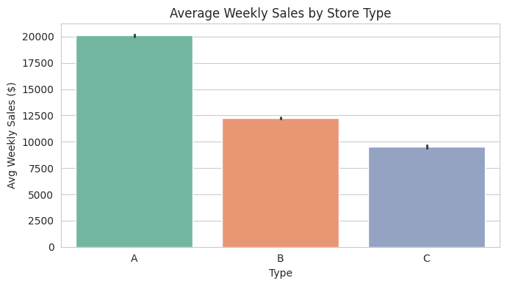
Chart 2: Average Weekly Sales by Store Type

The bar chart shows average weekly sales per department broken down by store type. Type A stores average roughly $20,100, far ahead of Type B at $12,237 and Type C at $9,520. Store type is therefore a first-order driver of sales and a strong candidate model feature. The statistically significant difference between types is later confirmed by the ANOVA hypothesis test.

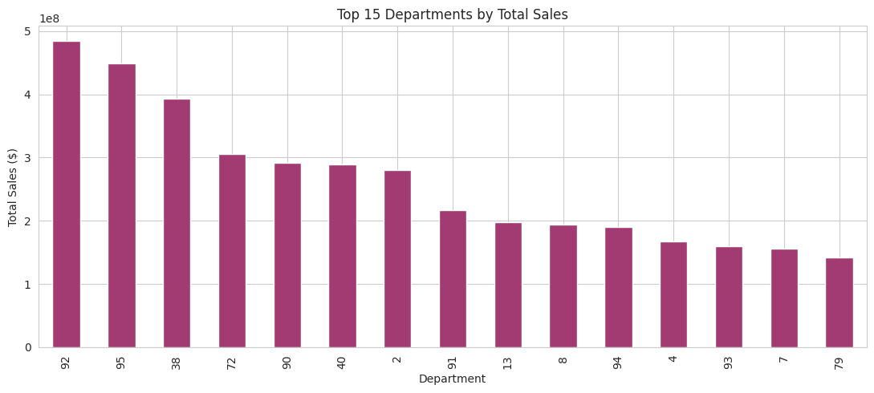
Chart 3: Top 15 Departments by Total Sales

The ranked horizontal bar chart shows the fifteen highest-grossing departments. Revenue is heavily concentrated. Departments 92 and 95 lead by a large margin, followed by Departments 38, 72, 90, 40, and 2. This concentration means that forecast accuracy and inventory attention should be prioritised on these top departments, where errors are most costly to the business.

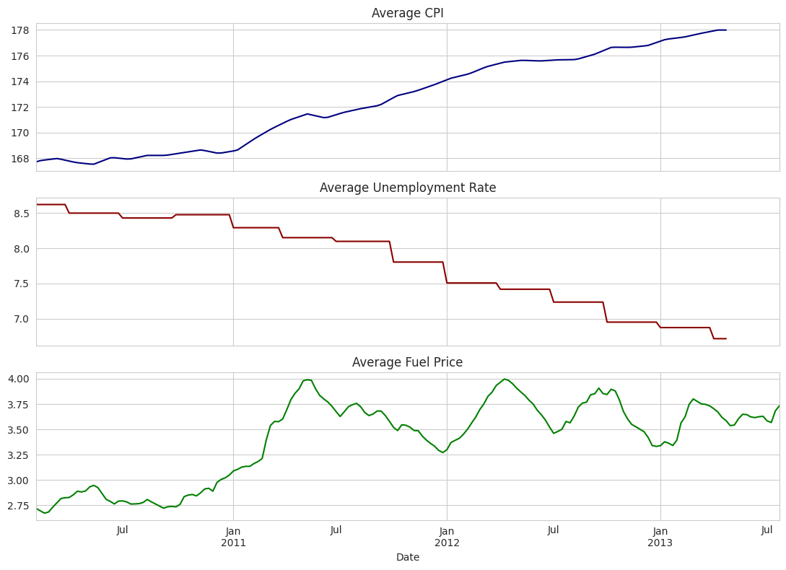
Chart 9: Economic Indicators Over Time (CPI, Unemployment, Fuel Price)

Three stacked line charts show the evolution of CPI, average unemployment rate, and average fuel price. These external signals provide macroeconomic context for demand shifts and are included as model features. Their modest individual correlations with sales, visible in the heatmap confirm they contribute secondary rather than primary predictive power.

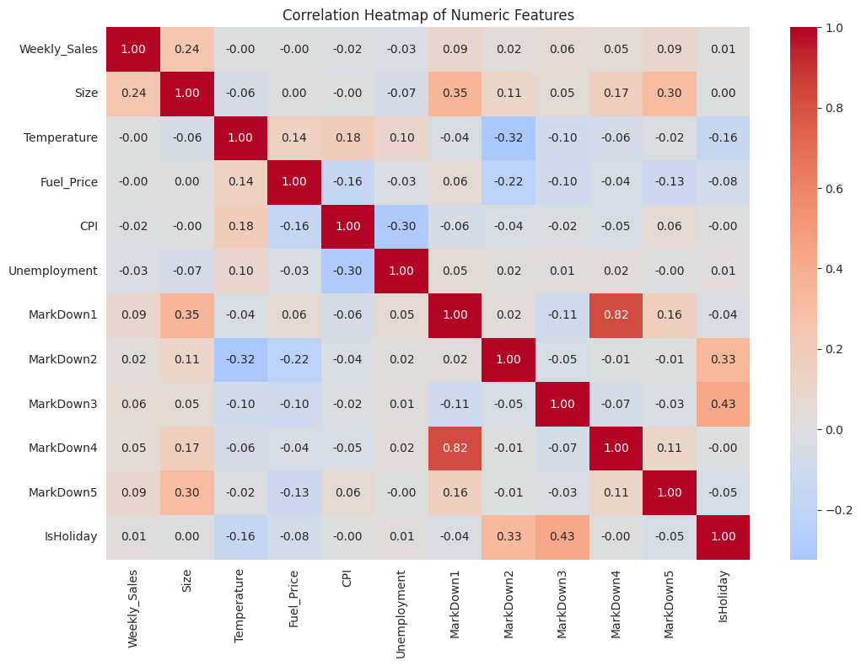
Chart 14: Correlation Heatmap of Numeric Features

The heatmap shows pairwise Pearson correlations across all numeric features. Weekly_Sales has its strongest positive correlation with Size (0.24), confirming larger stores sell more.

HYPOTHESIS TESTING

WORKFLOW OVERVIEW:
Three hypotheses drawn directly from the EDA observations are tested with appropriate statistical tests. Each pairs a null hypothesis (no effect) with an alternative (an effect exists) and is evaluated at the conventional 5% significance level. In every case the null is rejected, confirming the visual patterns with statistical evidence.

METHOD:
1. Hypothesis 1 tests whether holidays change average weekly sales using an independent two-sample t-test.
2. Hypothesis 2 tests whether store type affects weekly sales using one-way ANOVA, the correct choice when comparing means of three or more groups.
3. Hypothesis 3 tests whether store size is correlated with average sales using Pearson correlation.
4. For each test the p-value is compared against the 0.05 significance threshold and a decision to reject or retain H0 is stated.

HYPOTHESIS 1: Holidays Affect Sales:
H0: Mean weekly sales are equal on holiday and non-holiday weeks.
H1: They differ.
Test: Independent two-sample t-test.
Result: Holiday mean $17,035.82 vs Non-holiday mean $15,901.45. t = 7.00, p < 0.000001.
Reject H0 holidays raise average weekly sales by a statistically significant margin.

HYPOTHESIS 2: Store Type Affects Sales:
H0: Mean sales are equal across Types A, B, and C.
H1: At least one type differs.
Test: One-way ANOVA.
Result: Type A $20,100 vs Type B $12,237 vs Type C $9,520. F = 7,764.43, p ≈ 0.
Reject H0 store type is a powerful, significant determinant of sales level.

HYPOTHESIS 3: Store Size Correlates With Sales:
H0: Store size and average sales are uncorrelated.
H1: They are correlated.
Test: Pearson correlation.
Result: r = 0.807, p = 2.11 × 10⁻¹¹.
Reject H0 larger stores sell substantially more, a strong positive linear relationship.

FEATURE ENGINEERING & DATA PREPROCESSING

WORKFLOW OVERVIEW:
The cleaned master table is converted into a numeric, model-ready matrix. This stage covers missing-value treatment, outlier handling, categorical encoding, feature creation and selection, log transformation, standard scaling, PCA dimensionality reduction, train/test splitting, and anomaly detection.

HOW IT WORKS:
1. Missing markdown values are filled with zero, encoding the business meaning 'no promotion ran'. Trailing CPI and Unemployment gaps are forward filled to keep the series continuous.
2. Negative Weekly_Sales values (1,285 rows) are floored to zero as they represent returns/adjustments that are not valid demand. High outliers (35,521 rows, 8.4%) are retained because they are genuine holiday demand spikes the model must learn.
3. Store Type is label-encoded (A→0, B→1, C→2) and the holiday flag is cast to 0/1.
4. Lag_1 (previous week's sales) and Roll_4_avg (four-week rolling average) are engineered as the dominant predictive features.
5. Feature importance screening confirms Lag_1 (0.824) and Roll_4_avg (0.134) together account for 96% of signal.
6. A log1p transformation is applied to Weekly_Sales to reduce right skew (skew drops from 3.26 to -1.29).
7. Continuous features are standardized to zero mean and unit variance using StandardScaler.
8. PCA on the store level profile retains 83% of variance in two components (61.2% + 21.7%).
9. A time-aware train/test split is used: 338,738 rows for training (dates ≤ 13 Apr 2012) and 82,832 rows for testing (dates > 13 Apr 2012).

SCREENSHOT:
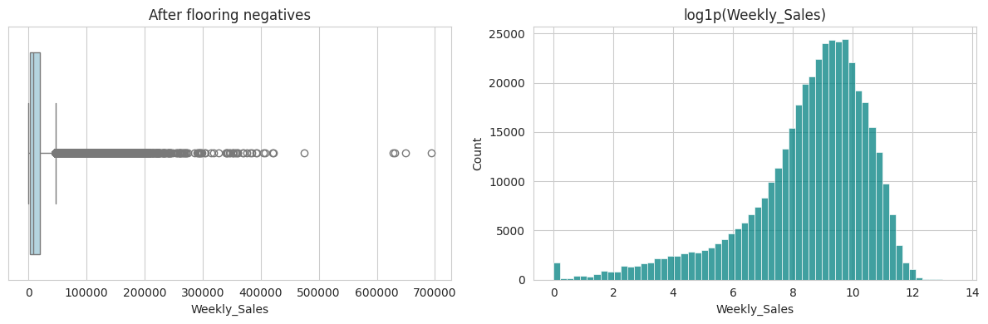
Outlier Handling: Weekly Sales after flooring negatives (left) and log1p distribution (right)

The left boxplot shows the Weekly_Sales distribution after the 1,285 negative values have been floored to zero. The right histogram shows the log1p-transformed sales, which follows a near normal distribution (skew -1.29) compared to the original heavily right-skewed distribution (skew 3.26). The upper outliers are retained as they represent genuine holiday demand spikes.

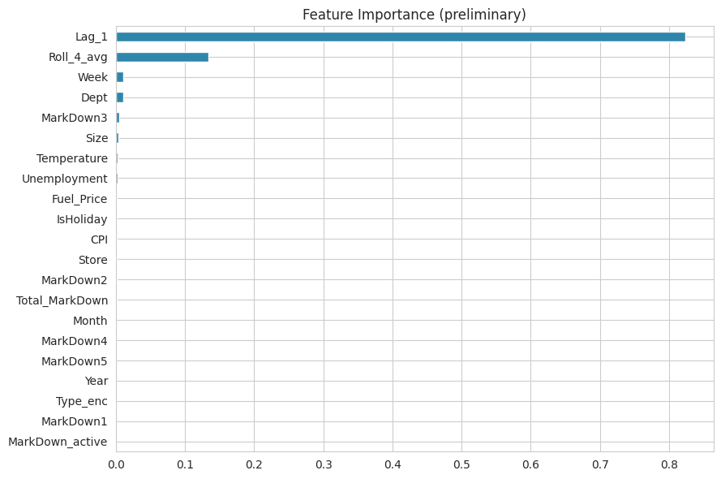
Feature Importance Preliminary Screening

The horizontal bar chart ranks all candidate features by importance score from a preliminary tree model. Lag_1 (previous week's sales) dominates with a score of 0.824, followed by Roll_4_avg (four-week rolling average) at 0.134. Week and Dept each contribute around 0.01. External economic features like CPI, Unemployment, and Fuel_Price contribute modestly but meaningfully at 0.001–0.002 each.

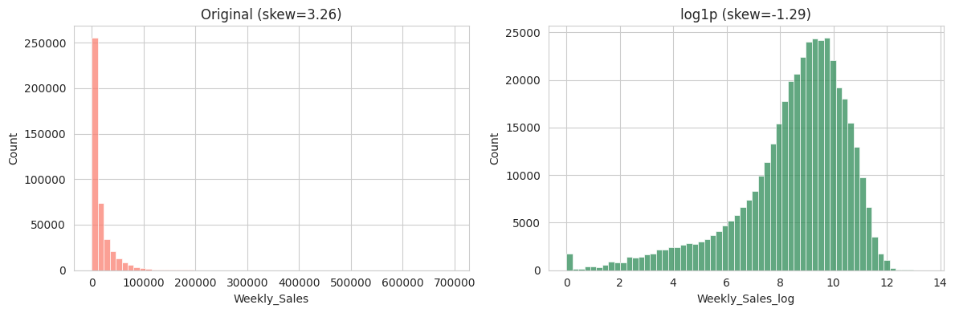
Data Transformation: Original Distribution vs Log1p Transformed Distribution

The left histogram shows the original Weekly_Sales distribution with extreme right skew (skew = 3.26), where the vast majority of values cluster near zero with a very long tail. The right histogram shows the same data after log1p transformation, producing a much more symmetric, near-normal distribution (skew = -1.29). This transformation stabilises variance and improves model convergence for all three regression algorithms.

UNSUPERVISED LEARNING SEGMENTATION & MARKET BASKET ANALYSIS

A. STORE SEGMENTATION:
1. Each store is profiled on average sales, sales volatility, store size, and local economic indicators.
2. The optimal number of clusters is selected using the elbow method on inertia and the silhouette score.
3. K-Means is run with k=3, which produces a clean three-cluster solution: High-Volume (large), Mid-Tier, and Low-Volume (small).
4. PCA reduces the store profile to two dimensions for visualisation, retaining 83% of variance.
5. Cluster quality is validated with three internal metrics: Silhouette (0.343), Davies-Bouldin (1.118), and Calinski-Harabasz (29.8).

SCREENSHOT:
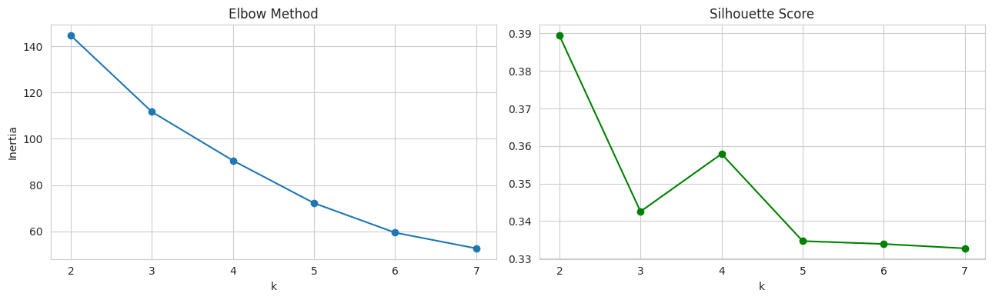
K-Means: Elbow Method and Silhouette Score across k=2 to k=7

The elbow plot shows inertia decreasing as k increases, with a visible bend suggesting k=3 as the optimal choice. The silhouette score plot shows the highest value at k=2 but a secondary local maximum at k=4; combined with business interpretability, k=3 is selected. The three-cluster solution maps cleanly to high-volume large-format stores, mid-tier stores, and small low-volume stores.

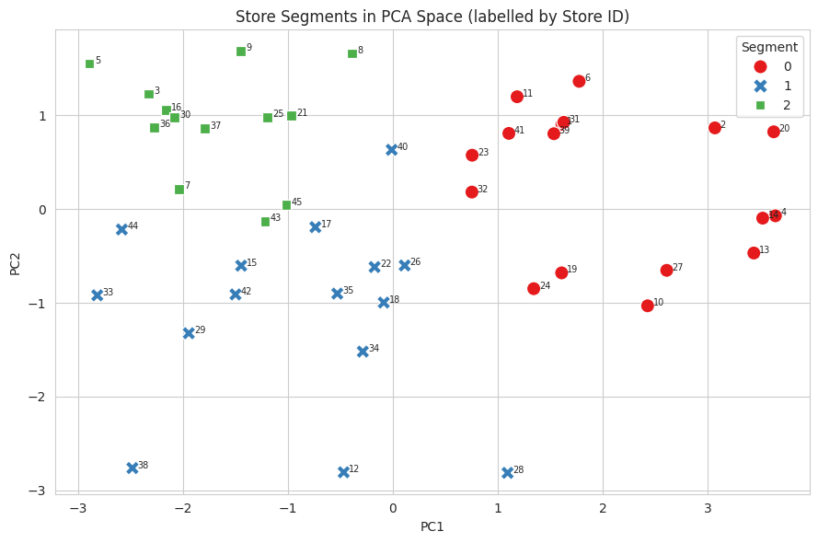
Store Segments in PCA Space
The scatter plot projects all 45 stores onto the first two principal components (PC1 and PC2 together explaining 83% of variance). Three clearly separated clusters are visible: red circles (Segment 0) are the high-volume large stores concentrated in the positive PC1 region; blue crosses (Segment 1) are the mid-tier stores spread across the middle; green squares (Segment 2) are the small low-volume stores in the negative PC1 region. Each store is labelled with its Store ID.
B. MARKET BASKET ANALYSIS:
1. Since transaction level baskets do not exist, each (Store, Week) pair is treated as a basket.
2. A department is marked 'present' in a basket when its weekly sales exceed its own median
3. Apriori is run with min_support=0.4 and max_len=2, generating 278 frequent itemsets and 430 association rules.
4. Rules are ranked by lift; pairs with lift above 2.0 indicate departments that are more than twice as likely to have a strong week together than chance would predict.

SCREENSHOT:
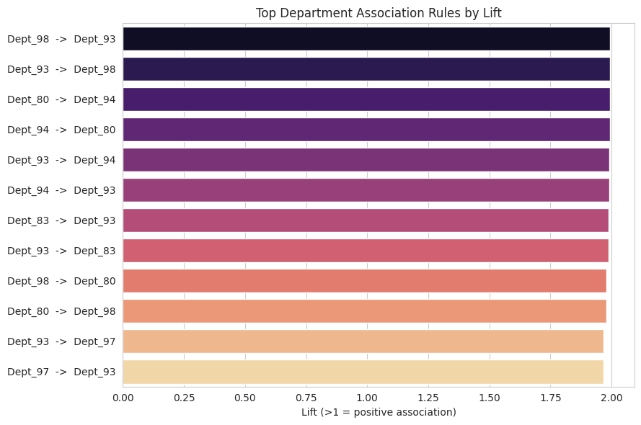
Top Department Association Rules by Lift

The horizontal bar chart shows the top 12 department association rules ranked by lift value. The strongest associations are between Dept_98 and Dept_93 (lift ≈ 2.0), Dept_80 and Dept_94 (lift ≈ 2.0), and Dept_93 and Dept_94 (lift ≈ 2.0). All shown pairs exceed lift = 1.9, confirming consistent co-surge behaviour. These pairs are strong candidates for co-promotion, coordinated shelf placement, and joint inventory planning.

ML MODEL IMPLEMENTATION DEMAND FORECASTING

METHOD:
1. All three models are trained on the 338,738-row training set (dates ≤ 13 Apr 2012) and evaluated on the 82,832-row test set (dates > 13 Apr 2012).
2. Linear Regression (with Ridge regularisation) is used as the baseline model.
3. Random Forest Regressor is trained as the first ensemble model.
4. Hist Gradient Boosting Regressor is trained as the second ensemble model and selected as the final production model.
5. Each model is evaluated on R², RMSE, MAE, and holiday weighted MAE (WMAE).
6. Hyperparameter tuning is performed for all three models using cross-validation.
7. The best model is saved as best_sales_forecast_model.pkl and reloaded for a sanity check prediction on unseen rows.

ML MODEL 1: LINEAR REGRESSION:
The Ridge regularised linear baseline achieves R² = 0.975, RMSE = 3,441, MAE = 1,796, WMAE = 1,851. Tuning (best alpha = 100) leaves performance essentially unchanged at WMAE = 1,849, indicating the linear model is not over-fitting and has little remaining headroom.

SCREENSHOT:
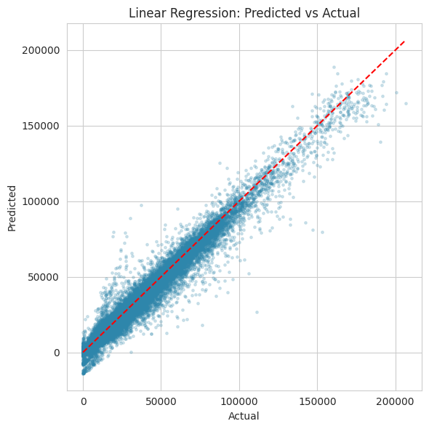
Linear Regression: Predicted vs Actual Weekly Sales

The scatter plot compares predicted values (y-axis) against actual weekly sales (x-axis) for the Linear Regression model on the held-out test set. Points cluster tightly along the red dashed perfect prediction line across the full range, confirming the model captures the dominant sales structure. The slight spread at higher sales values indicates modest under-prediction of the largest holiday demand spikes.

ML MODEL 2: RANDOM FOREST:
The Random Forest improves on the baseline, achieving R² = 0.980, RMSE = 3,102, MAE = 1,439, WMAE = 1,506 the lowest plain MAE of the three models. A randomised hyperparameter search confirmed these settings without materially changing the score, showing the ensemble is stable.

SCREENSHOT:
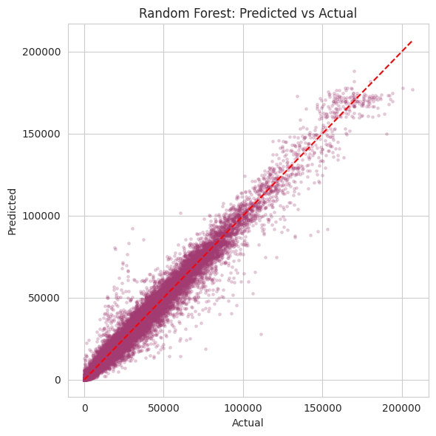
Random Forest: Predicted vs Actual Weekly Sales

The scatter plot for Random Forest shows tighter clustering around the red dashed perfect prediction line compared to Linear Regression, particularly in the 0–$100,000 range where the majority of records sit. The improved alignment across all sales levels confirms the ensemble's ability to capture non-linear interactions between department, store size, and seasonal timing.

ML MODEL 3: HIST GRADIENT BOOSTING:
Histogram-based Gradient Boosting achieves R² = 0.978–0.979, RMSE = 3,221, MAE = 1,543, WMAE = 1,589 after grid search tuning (best: learning_rate=0.1, max_depth=10, max_iter=250). It is selected as the final production model for its balance of accuracy, training speed, and scalability on the 420k-row dataset.

SCREENSHOT:
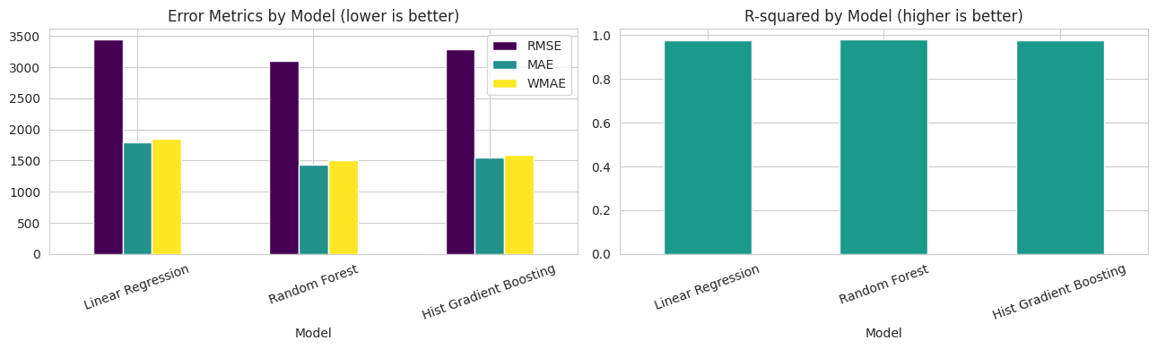
Model Comparison: Error Metrics and R-squared across all three models

The left grouped bar chart compares RMSE, MAE, and WMAE across all three models. Random Forest achieves the lowest RMSE (3,102) and MAE (1,439), while Hist Gradient Boosting is close behind. Linear Regression has the highest error across all three metrics. The right bar chart shows R² values: all three models exceed 0.975, but both ensemble models surpass 0.978 confirming clear superiority over the linear baseline.

MODEL PERFORMANCE SUMMARY:
- Linear Regression R²: 0.975 | RMSE: 3,441 | MAE: 1,796 | WMAE: 1,851
- Random Forest R²: 0.980 | RMSE: 3,102 | MAE: 1,439 | WMAE: 1,506
- Hist Gradient Boosting R²: 0.979 | RMSE: 3,221 | MAE: 1,543 | WMAE: 1,593

SUMMARY

1. Data Understanding: Three source tables merged to 421,570 sales records, 45 stores, 81 departments, 143 weeks. Structural missingness identified in all five MarkDown columns (50–64%).
2. Data Wrangling: All three tables merged into a single table.
3. Hypothesis Testing: All three null hypotheses rejected, holidays significantly raise sales, store type significantly affects sales, store size strongly correlates with sales.
4. Feature Engineering: Negatives floored, log1p transformation applied, and engineered as dominant features.
5. Unsupervised Learning: Three store segments identified. 430 department association rules mined with top pairs showing lift.
6. ML Forecasting: Hist Gradient Boosting selected as final model.

